Grace Basket 2026 Landing Page Feedback
Below are edits needed on the landing page:
- Change all US spelling to UK spelling
  - For example, replace neighbor with neighbour here:

- I like the page layout, but there are too many repetitions.

- Allow all three mandates (pictured below, to the right) to appear in the 2nd section of the page, where the mandates are first mentioned.
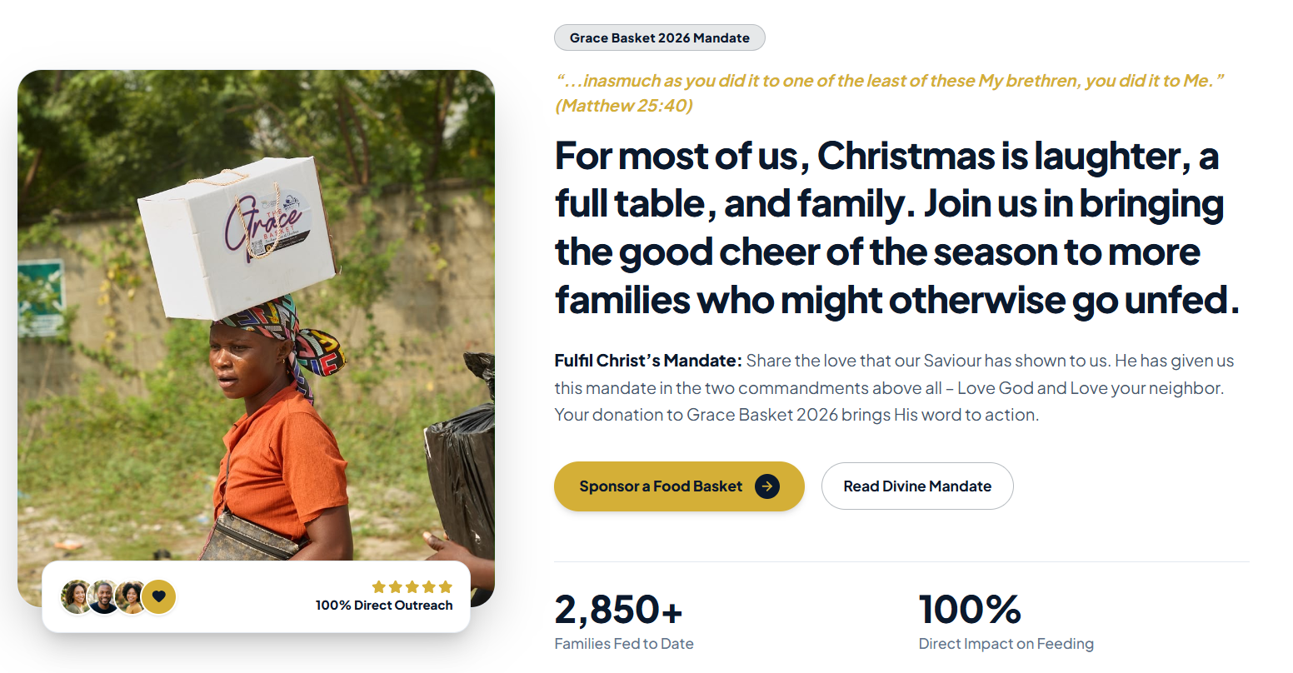
- Replace the subheading copy from section 3, with the subheading from section 4
(Replace "Your gift goes towards feeding people this Christmas who might otherwise go unfed. Every amount is prayerfully deployed" with "God never forgets your labour..."

- Delete all of section 4 (pictured below)
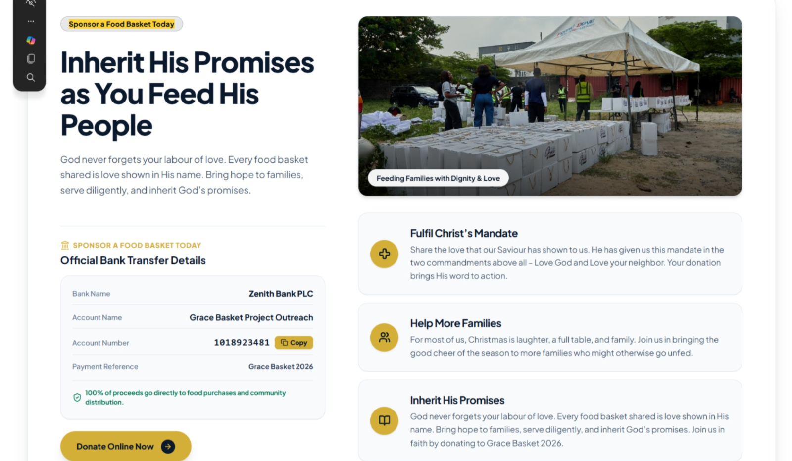
- In the feed 5 families section update ‘Handwritten Christmas Scripture Card & Prayer’ with ‘On the day intercessory prayer support’
- Since we are deleting section 4, the payment details should all link through to the pop-up window, and not to the official bank details that were included in section 4
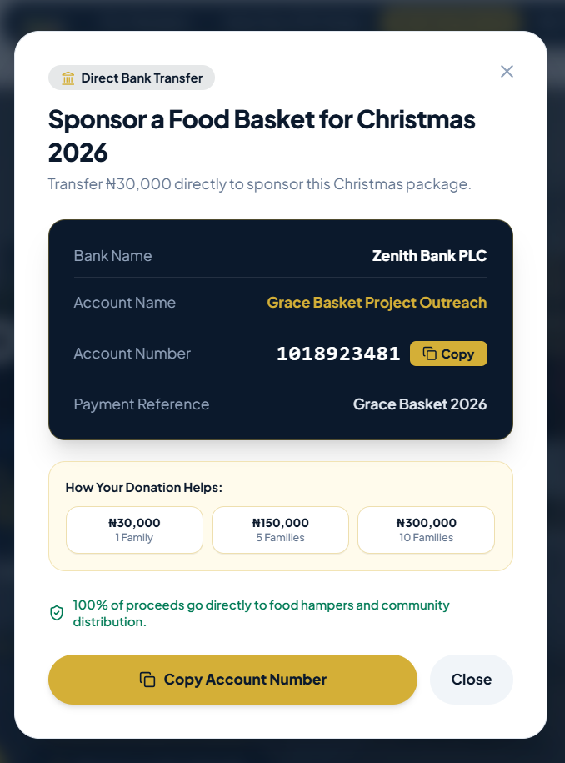

- On quick navigation at the top and bottom footer of the page delete ‘account details’, ‘inherit his promises’

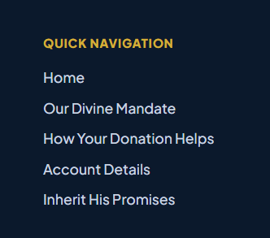

Comments on specific pages
- Every hamper kit contains the same thing. However, the description on each page makes it appear as if the content when you gift 5 families is different to when you gift 1 family
Feeding one family
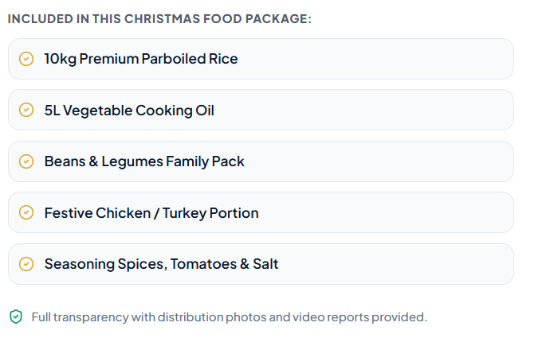
Feeding five families
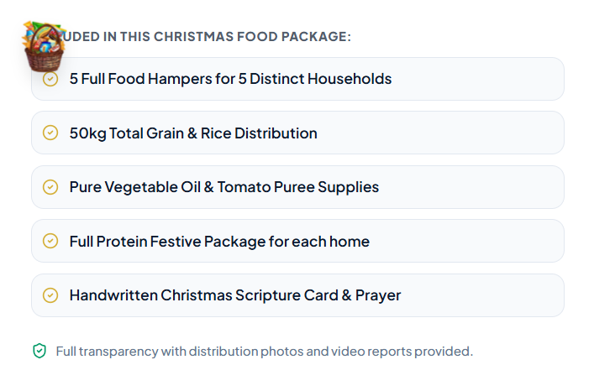
Feeding 10 families
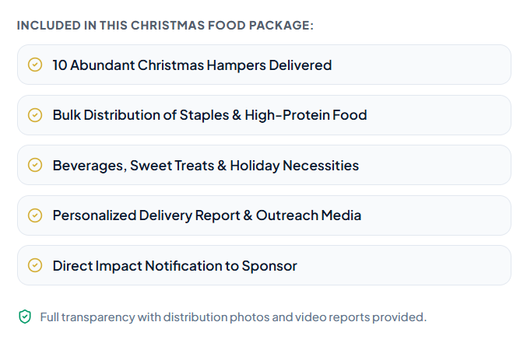
Community partner
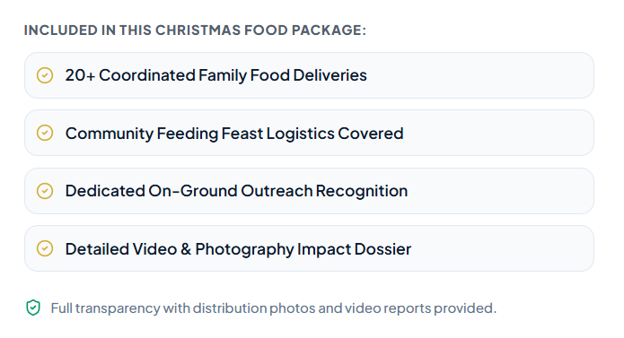
Therefore, we need to confirm the following with Hepzibah and pastor Crystal
- Standard weight per package
- The usual type of content per package
- We don’t collect sponsor contact details so it’s not possible to contact anyone who donated
- Previously, we never provided a handwritten Christmas scripture card & prayer. However, we do have a prayer section on the day, where people attending can be prayed for by our intercessory team. I’ve given alternative copy in the section above
- The family community bullets are way off.
Knowing this information will allow for more appropriate/accurate bullet points on the description pages.

Items to confirm with the Grace Basket group members, mainly Pst. Crystal, Ma Ndidi, and Sis Hepzibah
- 100% of your gift directly buys grain hampers, turkey portions, and vegetable oils for Christmas
- Bank details, name, number, and bank
- 2,850+ Families Fed to Date
- We usually do not create a report or broadcast the event, so I’m not sure we can do the things mentioned below; it will need to be confirmed with Pst Crystal (and maybe deleted from the site).

